Ideation Phase
Brainstorm & Idea Prioritization Template

Date | 27 June 2025
Team ID | LTVIP2025TMID53093
Project Title | HouseHunt: Finding Your Perfect Rental Home
Maximum Marks | 4 Marks

Brainstorm & Idea Prioritization Template

Project Title: House Hunt – Finding Your Perfect Rental Home

Step 1: Team Gathering and Problem Statement Selection
The team came together with a mix of frontend, backend, and design skills. We discussed real-life challenges in finding rental homes and decided to build a platform that helps people easily search for and find rental properties.

✅ Final Problem Statement:
“To create a web application that helps users find rental homes based on location, budget, and preferences.”

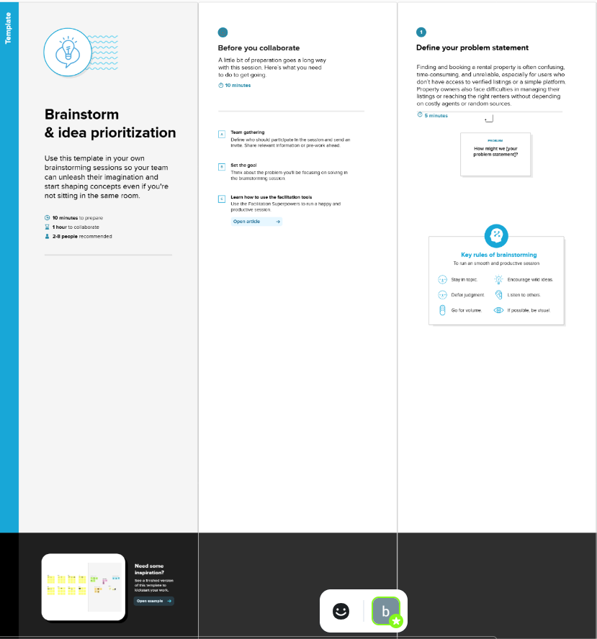

Step 2: Brainstorming Ideas and Grouping
We listed as many ideas as possible—no filtering, just creative thinking. Then, we grouped the ideas into four main categories:

💡 Feature Ideas:
1. Search and Filters
- Search by city or area
- Filters for price, number of rooms, pet-friendly, etc.
2. User Features
- Login and register

- Contact property owner
3. Admin Features
- Admin login
- Add, edit, or remove property listings
4. Future Ideas
- Email alerts for new listings
- Virtual property tours
- Chat with landlords
- AI-based recommendations
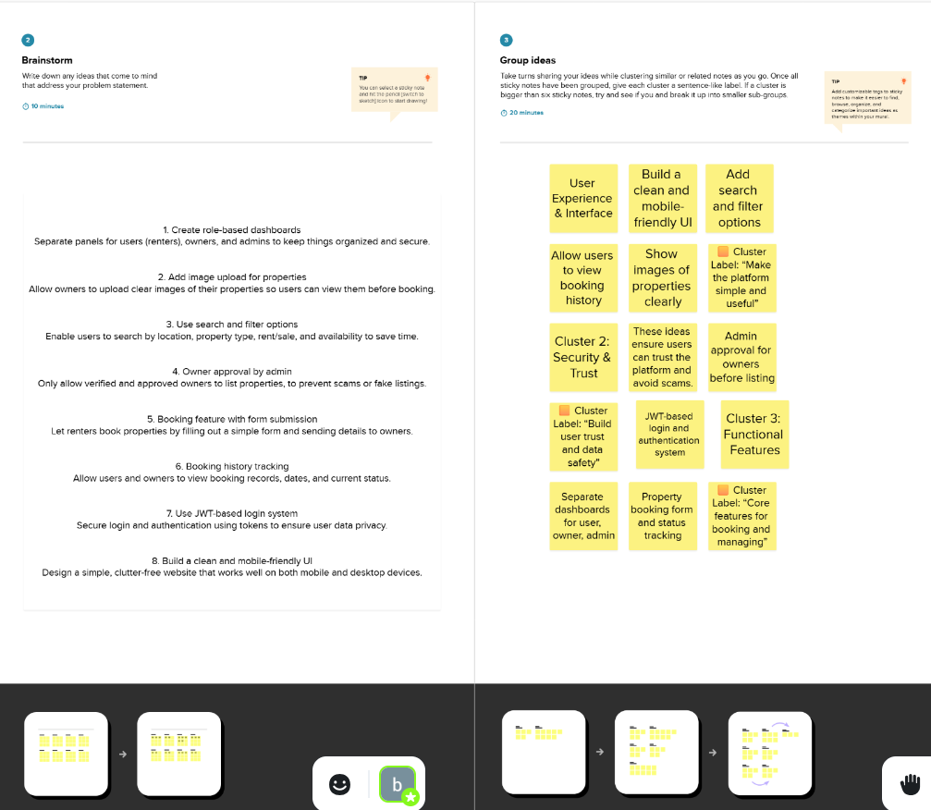

Step 3: Idea Prioritization
We used simple categories: Must Have, Nice to Have, and Future Features.

Must Have (for Version 1.0)
- Property search with filters
- Property details page
- User login & registration
- Admin dashboard for listings

Nice to Have
- Contact owner button
- Responsive mobile design

Future Features
- Email alerts for new listings
- Virtual property tours
- Chat with landlords
- AI recommendations
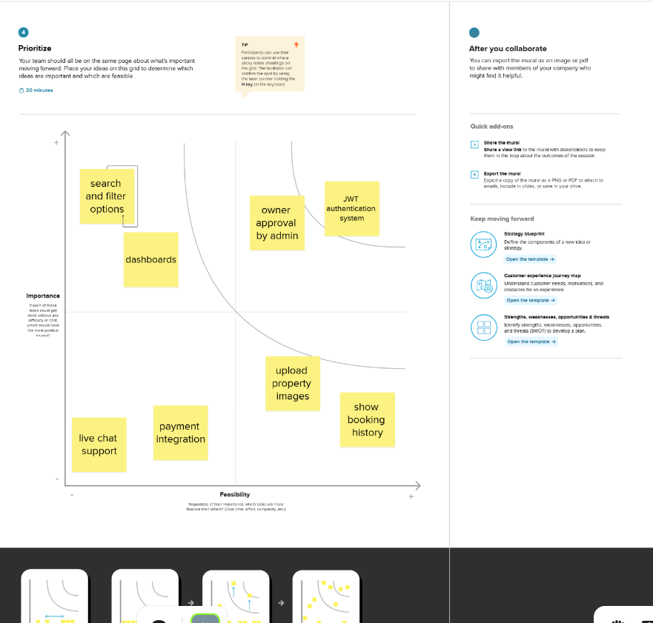

✅ Summary
The team used brainstorming to come up with many creative ideas. We then picked the most important features to build first. The rest will be added in later updates. This approach helps keep the project focused and achievable

